A Minor Project Report

On

**VEHICLE TRACKING SYSTEM USING GPS AND GSM**

SUBMITTED IN PARTIAL FULFILLMENT FOR THE AWARD OF DEGREE OF

**Bachelor of Technology**

**IN**

**Electronics and Communication Engineering**



**Submitted By:**

**rishabh Kumar srivastava(9915102125)**

**atul garg (9915102098) Under the Guidance Of**

**aryan koodi (9915102097) Mr.Yogesh kumar**

**DEPARTMENT OF ELECTRONICS AND COMMUNICATION ENGINEERING**

**JAYPEE INSTITUTE OF INFORMATION TECHNOLOGY, NOIDA (U.P.)**

**CERTIFICATE**

This is to certify that the minor project report entitled, **VEHICLE TRACKING SYSTEM USING GPS AND GSM** submitted by RISHABH KUMAR SRIVASTAVA, ATUL GARG and ARYAN KOODI in partial fulfillment of the requirements for the award of Bachelor of Technology Degree in **Electronics and Communication Engineering** of the Jaypee Institute of Information Technology, Noida is an authentic work carried out by them under my supervision and guidance. The matter embodied in this report is original and has not been submitted for the award of any other degree.

**Signature of Supervisor:**

**Name of the Supervisor:**

**ECE Department,**

**JIIT, Sec-128,**

**Noida-201304**

**Dated:**

**DECLARATION**

We hereby declare that this written submission represents our own ideas in our words and where other’s ideas or words have been included, have adequately cited and referenced the original sources. We also declare that we have adhered to all principles of academic honesty and integrity and have not misrepresented or fabricated or falsified any idea/data/fact/source in our submission.

Place:

Date:

Name:

Enrollment:

Name:

Enrollment:

Name:

Enrollment:

**SYNOPSIS**

This paper describes about how we can track the vehicle, we need to send a message to GSM device, by which it gets activated. It also gets activated by detecting accident on the IR sensor, by detecting fire on the temperature sensor, by detecting theft connected to vehicle. Parallely deactivates GPS with the help of relay .Once GSM gets activated it takes the last received latitude and longitude positions values from the buffer and sends a message to the particular number or laptop which is predefined in the program. Once message has been sent to the predefined device the GSM gets deactivated and GPS gets activated.

**ACKNOWLEDGEMENT**

We have taken efforts in this project. However, it would not have been possible without the kind support and help of many individuals and organizations. We would like to extend our sincere thanks to all of them.

We are highly indebted to **Mr. Yogesh Kumar** for his guidance and constant supervision as well as for providing necessary information regarding the project and also for his support in completing the project.

We would like to express our gratitude towards staff members of the **JAYPEE INSTITUTE OF INFORMATION TECHNOLOGY, NOIDA** for their kind co-operation and encouragement which help us in the completion of this project.

**TABLE OF CONTENTS**

**Title Page------------------------------------------------------------I**

**Certificate----------------------------------------------------------II**

**Declaration-------------------------------------------------------III**

**Synopsis-----------------------------------------------------------IV**

**Acknowledgment-------------------------------------------------V**

**Table of Contents ------------------------------------------------1**

**Introduction-------------------------------------------------------3**

**Literature Survey-------------------------------------------------4**

**CHAPTER 1--------------------------------------------------------5**

**1.1 Hardware Description-----------------------------------5**

**1.2 Software Description ------------------------------------7**

**CHAPTER 2------------------------------------------------------8**

**2.1 Methodology----------------------------------------------8**

**2.1.1 Block Diagram-------------------------------------9**

**2.2 Flowchart/Working ------------------------------------10**

**CHAPTER 3-----------------------------------------------------11**

**3.1 Circuit (Proteus) ----------------------------------------11**

**CHAPTER4------------------------------------------------------12**

**4.1 Conclusion------------------------------------------------12**

**4.2 Future Scope---------------------------------------------13**

**REFERENCES--------------------------------------------------14**

**APPENDICES---------------------------------------------------15**

**INTRODUCTION**

Vehicle tracking system main aim is to give Security to all vehicles. Accident alert system main aim is to rescuing people in accidents. This is improved security systems for vehicles. The latest like GPS are highly useful now days, this system enables the owner to observe and track his vehicle and find out vehicle movement and its past activities of vehicle.

This new technology, popularly called vehicle Tracking Systems which created many wonders in the security of the vehicle. This hardware is fitted on to the vehicle in such a manner that it is not visible to anyone who is inside or outside of the vehicle. Thus it is used as a covert unit which continuously or by any interrupt to the system, sends the location data to the monitoring unit.

When the vehicle is stolen, the location data from tracking system can be used to find the location and can be informed to police for further action. Some Vehicle tracking System can even detect unauthorized movements of the vehicle and then alert the owner. This gives an edge over other pieces of technology for the same purpose.

This accident alert system in it detects the accident and the location of the accident occurred and sends GPS coordinates to the specified mobile, computer etc. The fire detector circuit in it is used to detect fire in the vehicle, if the temperature inside the vehicle goes above a certain limit then a warning will be automatically send to the intend receiver. The infrared sensor which is additionally interfaced to the microcontroller is used to detect the obstacles and accidents, in any case if any mishap occurs then its warning will be directly send to the intended receiver.

When a request by user is sent to the number at the modem, the system automatically sends return reply to that particular mobile indicating the position of the vehicle in terms of latitude and longitude.

**LITERATURE SURVEY**

The proposed system is used for positioning and navigating the vehicle with an accuracy of 10

m. The Exact location is indicated in the form of latitude and longitude along with the exact

Navigated track on Google map.

The system tracks the location of particular vehicle and sends to users mobile in form of data and also to microcontroller. The arrived data, in the form of latitude and longitude is used to locate the Vehicle on the Google maps and also we can see the output on the LCD

It is mainly benefit for the companies which are based on transport system. Since it can show the position of all vehicles in real time, so that they can create the expected data accordingly. These tracking system can store the whole data where the vehicle had gone, where did it stop, how much time it take at every stop and can create whole data analysis. It is also used in buses and trains, to estimate how far are they, how much time it takes for them to come to a particular stop. These systems are used to data capture, data storage, data analysis and finally data transfer. By adding additional sensors such as temperature sensor and infrared sensors the system can be enabled to detect fire , theft and obstacles.

Tracking in India is mainly used by transport systems, taxi companies, traffic operators. Taxi operators use this to estimate how far the vehicle is from a particular area and send this information to call centers and they can inform general public about the distance of the taxi location and time it takes tom come to them. Another use is for traffic police if this system is located in every vehicle they can estimate the traffic by looking on the map and if any accident is detected then they can route the traffic in to another way. This is how tracking is useful because India is one of busy traffic countries and this system can control many of the traffic problems.

**CHAPTER 1**

**1.1 HARDWARE DESCRIPTION**

**ARDUINO UNO:**

A microcontroller board, contains on-board power supply, USB port to communicate with PC, and an Atmel microcontroller chip. It simplifies the process of creating any control circuit of any system which generally takes complex design and implementation it is user friendly, cost effective, easy to program, and flexible as it can process any type of nork Software to program Arduino Uno is also free.

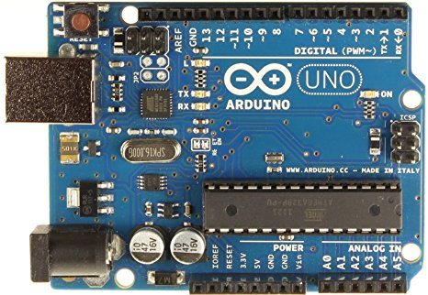

Fig.1.1 Arduino Board

**BLUETOOTH MODULE:**

Bluetooth module is used to connect one device to another device with wireless technology. We are using HC-05 because it is cheaper and affordable but we can also use HC-04 and HC-06.

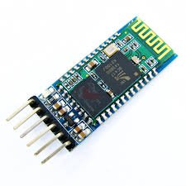

Fig.1.2 Bluetooth Module

**GPS MODULE:**

GSM module is used for transmission of message seeking assistance. GSM cannot be used in oceans as towers cannot be placed in oceans. Thus CDMA network or satellites can be used for message transmissions. When vessel crosses border, the stored message along with current latitude and longitude positions is sent to the desired GPS module which is stored already.

We are using GPS module NEO 6M as it is cheap and user friendly.

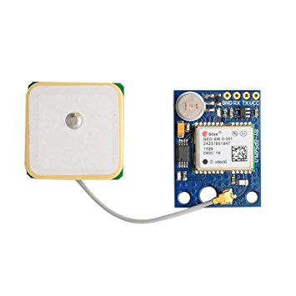

Fig1.3 GPS Neo 6-M

**GSM MODULE:**

A **GSM modem** is a specialized type of modem which accepts a SIM card, and operates over a subscription to a mobile operator, just like a mobile phone. From the mobile operator perspective, a GSM modem looks just like a mobile phone.

When a GSM modem is connected to a computer, this allows the computer to use the GSM modem to communicate over the mobile network. While these GSM modems are most frequently used to provide mobile internet connectivity, many of them can also be used for sending and receiving SMS. GSM modem can be a dedicated modem device with a serial, USB or Bluetooth connection, or it can be a mobile phone that provides GSM modem capabilities.

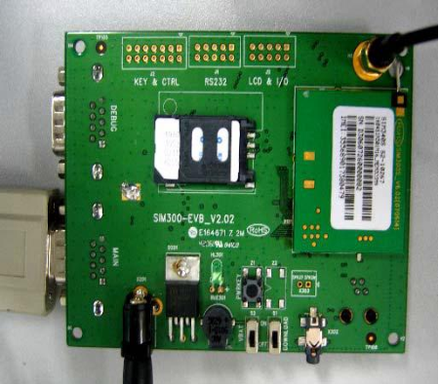

Fig.1.4 GSM Module (Sim300)

**BATTERY:**

There are different types of batteries for different purposes so for arduino for working we used general AA size DC battery.

**OTHER HARDWARE:**

Wires(M-F), Car chassis, Tyres, Breadboard etc.

**1.2 SOFTWARE DESCRIPTION**

**ARDUINO IDE:**

Arduino consists of both a physical programmable circuit board (often referred to as a microcontroller) and a piece of software, or IDE (Integrated Development Environment) that runs on your computer, used to write and upload computer code to the physical board.

**PROTEUS:**

The software is used mainly by electronic design engineers and electronic technicians to create electronic schematics and electronic prints for manufacturing printed circuit boards.

**CHAPTER 2**

**2.1 METHODOLOGY:**

The project consists of GPS receiver and GSM modem with a micro controller. The whole system is attached to the vehicle. In the other end (main vehicle station) one GSM mobile phone is attached to the computer with VB application. So the GPS system will send the longitudinal and altitude values corresponding to the position of vehicle to GSM Modem.

Imagine the bus has left Bangalore at 6 o clock in the morning. If the officer in charge for that vehicle wants to know where the vehicle is, he will come to the computer and click on the vehicle number on the VB program .The VB program will send an SMS to the vehicle number.

The SMS sent would come through the GSM service provider and then reach the vehicle, which is traveling, because the vehicle has a GSM device with sim card. This GSM modem will receive the SMS and send to the microcontroller in the vehicle. The microcontroller will receive this SMS and compare the password and the command. If every thing matches then it will perform the request required by the office.

A place name is assigned for each longitude & latitude. The GSM receiver in the vehicle office receives these data & gives to the PC through serial port. The VB program in the PC checks this data with its database & displays the details of the vehicle on the screen. The device is password controlled i.e. person who knows the device password only able to operate. In case of any mishaps such as fire, theft or obstacle, the device will automatically will send an alert to the registered number i.e., the number that is feeded into the memory of microcontroller.

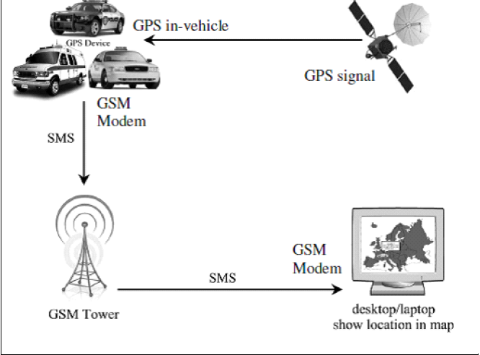

Fig.2.1 Methodology diagram of out project

**2.1.1 BLOCK DIAGRAM**

**Antenna**

**MICRO- CONTROLLER**

**AT mega 328**

**GPS**

**POWER SUPPLY**

**GSM MODULE**

**Antenna**

Fig.2.2 Block Diagram of Vehicle tracking System

2**.2 FLOWCHART/WORKING:**

**START**

**GPS, GSM ON**

**GSM wait for Request**

**VALID**

**NO**

**YES**

**GPS on gets data**

**GSM gets DATA and SEND to USER**

**USER receives DATA**

**END**

**CHAPTER 3**

**3.1 CIRCUIT (IN PROTEUS)**

**CONCLUSION AND FUTURE SCOPE**

**CONCLUSION:**

Vehicle tracking system makes better fleet management and which in turn brings large profits. Better scheduling or route planning can enable you handle larger jobs loads within a particular time. Vehicle tracking both in case of personal as well as business purpose improves safety and security, communication medium, performance monitoring and increases productivity. So in the coming year, it is going to play a major role in our day-to-day living.

Main motto of the project is to incorporate different types of sensors so that they help in decrease the chances of losing life in such accident which we can’t stop from occurring. Whenever accident is alerted the paramedics are reached to the particular location to increase the chances of life. This device invention is much more useful for the accidents occurred in deserted places and midnights. This vehicle tracking and accident alert feature plays much more important role in day to day life in future.

**FUTURE SCOPE:**

* We can use the EEPROM to store the previous Navigating positions up to 256 locations and we can navigate up to N number of locations by increasing its memory.
* We can reduce the size of the kit by using GPS+GSM on the same module.
* We can increase the accuracy up to 3m by increasing the cost of the GPS receivers.
* We can use our kit for detection of bomb by connecting to the bomb detector.
* With the help of high sensitivity vibration sensors we can detect the accident. whenever vehicle unexpectedly had an accident on the road with help of vibration sensor we can detect the accident and we can send the location to the owner, hospital and police.
* We can use our kit to assist the traffic. By keeping the kits in the entire vehicles and by knowing the locations of all the vehicles.
* If anybody steals our car we can easily find our car around the globe. By keeping vehicle positioning vehicle on the vehicle.

**REFERENCES**

**[1]** Jim Isaac , the paper titled as “Advanced border alert system using GPS and with intelligent Engine control unit “International Journal of Electrical and Computing Engineering (IJECE) Vol. 1, Issue. 4, June 2015.

**[2]** S.Kiruthika, N.Rajasekaran the paper titled as “A Wireless mode of protected defense mechanism to mariners using GSM technology” International Journal of Emerging Technology and Innovative Engineering Volume I, Issue 5, May 2015 (ISSN: 2394 – 6598).

[3] G.Sivagnanam , A.J.Midhun, N.Krishna, G.Maria Samuel Reuben A.Anguraj5 “Coast guard alert and rescue system for international maritime line crossing of fisherman” at International Journal of Innovative Research in Advanced Engineering (IJIRAE) ISSN:2349-2163 Issue 2, Volume 2 (February 2015).

**[4]** NaveenKumar.M Ranjith.R The paper titled as “Border alert and smart tracking system with alarm using DGPS and GSM” International Journal of Emerging Technology in Computer Science

& Electronics (IJETCSE) ISSN: 0976-1353 Volume 8 Issue 1 –APRIL 2014**.**

[5] R.Karthikeyan, A .Dhandapani, U.Mahalingham “Protecting of Fishermen on Indian Maritime Boundaries”, Journal of Computer Applications ISSN: 0974 – 1925, Volume-5, Issue EICA2012-3, and February 10, 2012.

[6] K. Suresh Kumar, “Design of low cost maritime boundary identification device using gps system” International Journal of Engineering Science and Technology Vol. 2(9), 2010, 4665-4672.-2010.

[7] Abid khan and Ravi Mishra (2012) , “GPS – GSM Based Tracking System” International Journal of Engineering Trends.

**APPENDICES**

**ALGORITHM:**

#include <LiquidCrystal.h>

#include <TinyGPS.h >

#include <SoftwareSerial.h>

SoftwareSerial SIM900(7, 8);

SoftwareSerial myserial(9,10);

TinyGPS gps;

char input[13];

int count = 0;

boolean match = 0; // A variable to store the Tag match status

char database[13]={"get_location"};

int sum=0;

int i=0;

const int rs = 12, en = 11, d4 = 5, d5 = 4, d6 = 3, d7 = 2;

LiquidCrystal lcd(rs, en, d4, d5, d6, d7);

void setup()

{

Serial.begin(9600);

SIM900.begin(9600);

myserial.begin(9600);

}

void loop()

{

bool newData = false;

unsigned long chars;

unsigned short sentences, failed;

// For one second we parse GPS data and report some key values

for (unsigned long start = millis(); millis() - start < 1000;)

{

while (Serial.available())

{

char c = Serial.read();

//Serial.print(c);

if (gps.encode(c))

newData = true;

}

}

if (newData) //If newData is true

{

lcd.print(" Reading frm Gps");

float flat, flon;

unsigned long age;

gps.f_get_position(&flat, &flon, &age);

if(Serial.available())// check serial data ( RFID reader)

{

count = 0; // Reset the counter to zero

/* Keep reading Byte by Byte from the Buffer till the GPS Buffer is empty

or till 12 Bytes (the ID size of our Tag) is read */

// while(1)

//{

while( count < 12)

{

input[count] = myserial.read(); // Read 1 Byte of data and store it in the input[] variable

count++; // increment counter

delay(5);

}

/* When the counter reaches 12 (the size of the ID) we stop and compare each value

of the input[] to the corresponding stored value */

if(count == 12) //

{

count =0; // reset counter varibale to 0

//match = 1;

/* Iterate through each value and compare till either the 12 values are

all matching or till the first mistmatch occurs */

int i=0;int p;

//while(i<2)

//{

match=1;

while(count<12 && match !=0)

{

if(input[count]==database[count])

match = 1;

else

match= 0;

/* if the ID values don't match, set match variable to 0 and

stop comparing by exiting the while loop */

count++; // increment i

}

if(match == 1) // If match variable is 1, then it means the tags match

{

SIM900.print("AT+CMGF=1\r");

delay(400);

SIM900.println("AT + CMGS = \"+917834822414\"");// recipient's mobile number with country code

delay(300);

lcd.clear();

lcd.print("Sending location");

delay(1000);

SIM900.print("Latitude = ");

SIM900.print(flat == TinyGPS::GPS_INVALID_F_ANGLE ? 0.0 : flat, 6);

SIM900.print(" Longitude = ");

SIM900.print(flon == TinyGPS::GPS_INVALID_F_ANGLE ? 0.0 : flon, 6);

delay(200);

SIM900.println((char)26); // End AT command with a ^Z, ASCII code 26

delay(200);

lcd.clear();

lcd.print("Message Received");

delay(300);

lcd.clear();

SIM900.println();

}

lcd.clear();

}

}

}

}